(Approx. 2500 words)

Revisiting PartedMagic
By Dick Maybach, Member, Brookdale Computer Users’ Group, NJ
February 2017 issue, BUG Bytes
www.bcug.com
n2nd (at) att.net

For many years PartedMagic, http://partedmagic.com/, has been my principal computer maintenance tool for formatting and copying disks, recovering deleted files, and correcting file system errors. I always carry it with me in the form of a live USB memory stick, which also has a FAT-32 partition for moving files among computers. I last discussed this tool in April 2012 (all the date references in this article are to my earlier articles in Bytes, which are available at http://www.bcug.com). Although it’s no longer free, I think its power and ease of use easily justifies its $9 download cost. Similar tools are still free, and I reviewed two of these in May and June 2015; make an Internet search of “pc rescue tools” to find more.

Like other live-media tools, PartedMagic boots directly from a CD-ROM or a memory stick, which it uses like a hard disk, and it will run even if your system disk is seriously corrupted or even completely missing. However, to use a live CD or memory stick, you must set up your BIOS to boot from something other than your hard disk; see your computer manual or check the Internet for your computer.

When PartedMagic boots, you’ll see Screen 1.

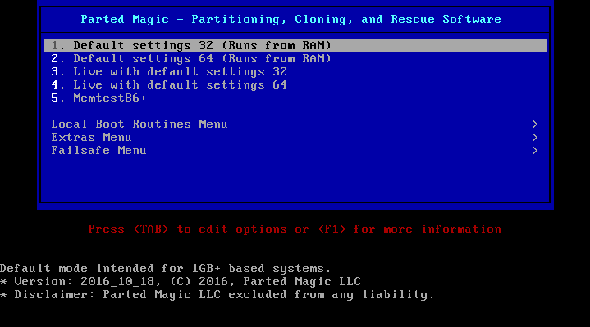
Screen 1. PartedMagic Boot Screen.

The default is highlighted, and is what you almost always should select. The two “Live” choices are for PCs with less than 1-Gbyte of RAM. Item 5 is a RAM test; although RAM failure is rare, it produces bizarre and unrepeatable symptoms when it does occur, making it worthwhile to run on a new computer. Screen 2 shows this test in progress; be sure to let it run for at least one complete cycle (as shown in Screen 2), which will take several minutes.

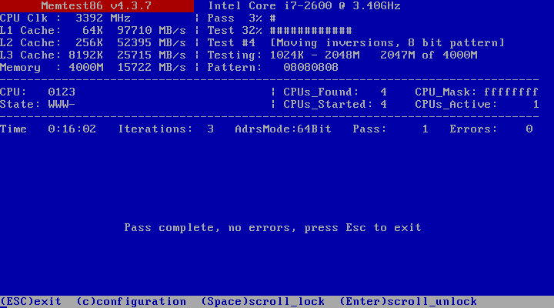
Screen 2. Memtest86 in Progress.

Assuming you choose one of the first four boot-menu options of Screen 1, you’ll see the display in Screen 3.

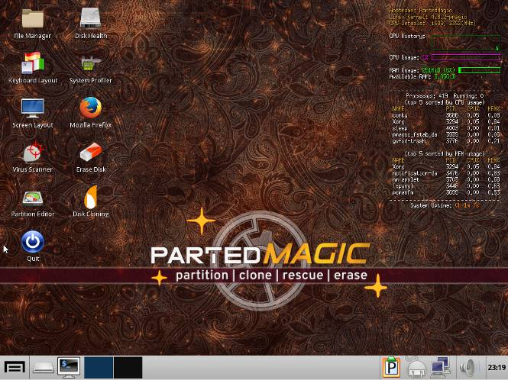
Screen 3. PartedMagic Main Screen.

The maintenance tools you'll use most often appear as desktop icons here; just double-click on one to start it.
- File Manager allows you to move, copy, rename, and delete files.
- Disk Health provides access to the SMART data where your disks record statistics of their internal errors and performance.
- Keyboard Layout allows you accommodate other keyboards than the standard US one.
- System Profiler details your hardware and network and lets you run performance tests.
- Screen Layout lets you change your monitor resolution.
- Mozilla Firefox is the standard Internet browser.
- Virus Scanner checks files for viruses, but can't correct them.
- Erase Disk performs a secure delete of all data on a disk.
- Partition Editor lets you add, delete, resize, move, and format disk partitions.
- Disk Cloning copies the entire contents of one disk to another or to a file.
- Quit does that.
I'll have more to say about many of these later. Clearly, you should use some with care; for example, you seldom want to format or erase your system disk. If you have used computers only casually, you might want to experiment on an old or secondary machine, rather than the one holding the only copies of your financial records and family pictures.

Several more items appear in the tool bar at the bottom. From left to right these are as follows, although they may appear in different order.
- Applications, access to all, not just the icons on the screen.
- The PartedMagic disk (usually a USB memory stick)
- Command-line terminal
- Select one of two virtual desktops
- Clipboard manager
- Power manager
- Network manager
- Volume control
- Clock and calendar
On the right of the screen is a display of the current activity on your computer, similar to what you see on the Windows Resource Manager.

All the tools on the main screen and many more are available in the Applications menu, shown in Screen 4.

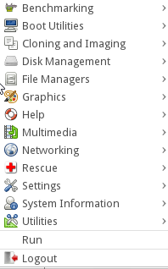
Screen 4. Applications Menu.

As the arrows on the right suggest, clicking on an item shows the individual programs available in that category.

The Disk Health application is safe, as it only displays information about your hard disk and doesn’t change anything. When it starts it shows an icon for each hard disk on the PC. Select one of these to see a summary of its characteristics, such as that shown in Screen 5.

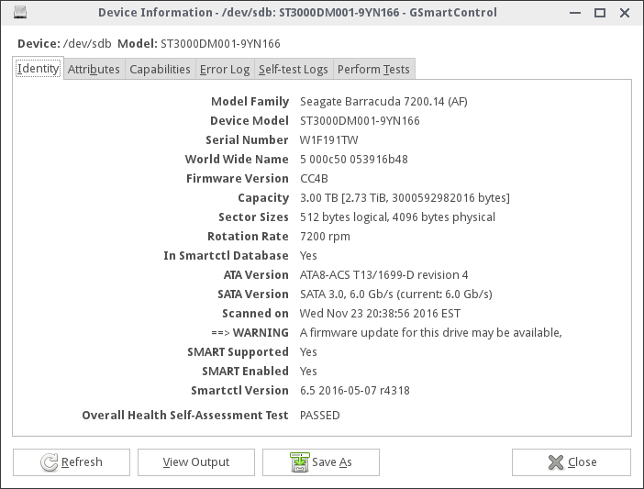
Screen 5. Disk Characteristics.

Look carefully at the tabs; if the disk has problems, one of these (most likely Attributes) will be in red. If the disk has failed, it’s icon in the opening menu will also be in red. For more on this application, see my May and June 2013 articles.

Another safe tool is Disk Usage Analyzer, available under System Information in the Application menu. Screen 6 shows the home directory of my Linux PC.

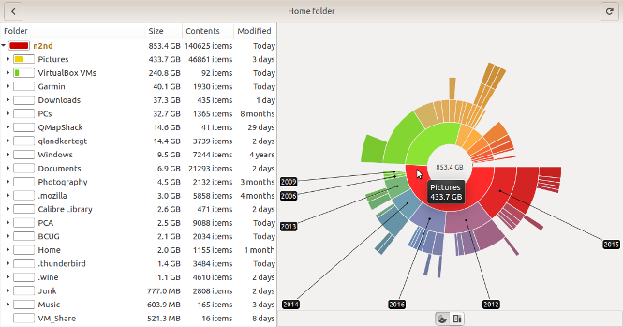
Screen 6. Disk Usage Analyzer Display of a Home Directory.

The ring closest to the center shows the directories and files in the main directory, the next ring their subdirectories, and so on. Placing the cursor on a segment displays its name and size and the names of its subdirectories. Similar information appears as text on the left. Here you can see that Pictures occupy the most space in my home directory. If I needed to free space, it would be most efficient to move my older pictures to an external disk.

Looking at the system area is less useful; for example, Screen 7 shows a Windows-7 disk. I seldom use this, which is why the User directory is so small. Unless you have one application hogging a lot of space, there is probably little you can do at this level, although just looking around can tell you about your system.
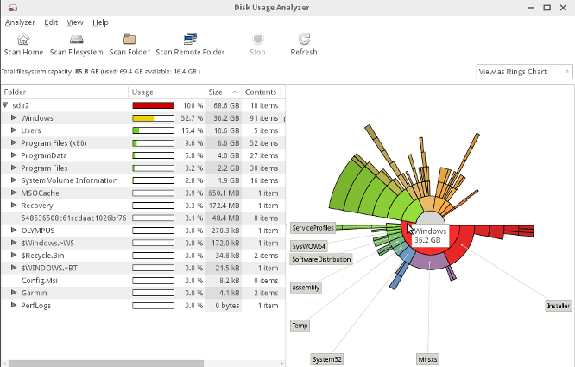
Screen 7. Windows Disk.

You can safely learn much about your system and check its speed with System Profiler on the main screen. Screen 8 shows its summary display.

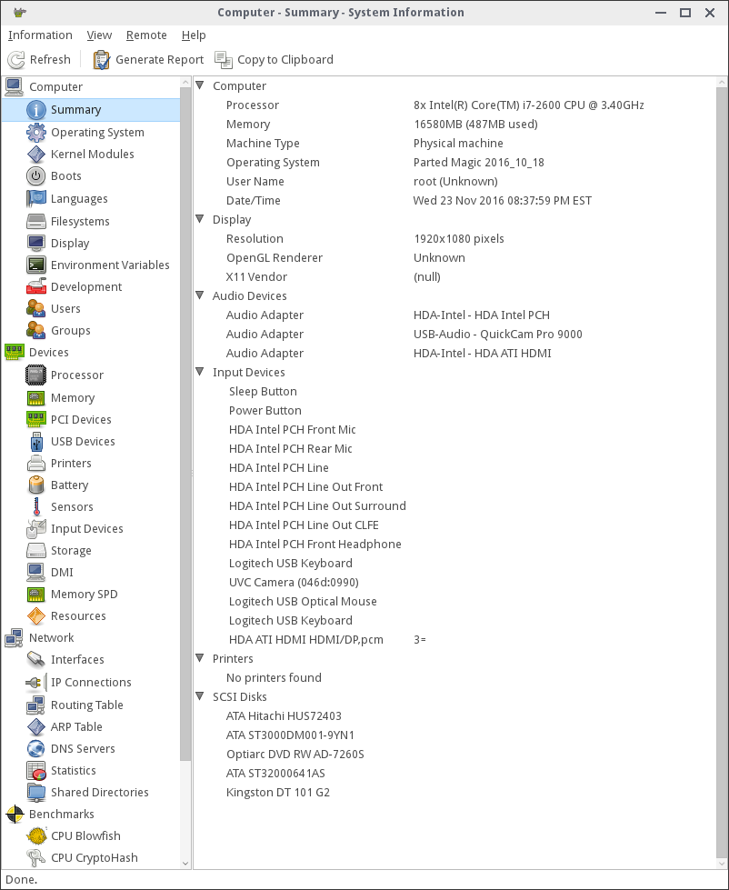
Screen 8. System Information Summary.

You can probably learn more about your hardware with less risk using this tool than you can by opening up your system case and poking around inside. There are also features that look at your software, but the results are misleading, as you will learn only about PartedMagic’s Linux operating system, not the one residing on the computer. The name of the program is “Hardinfo,” and you can install it on your PC if you want software information. The version shown here is for Linux (available in most repositories), but a similar one is available for Windows at http://www.usro.net/products/hardinfo/.

The File Manager operates much the same as Windows Explorer; see Screen 9.

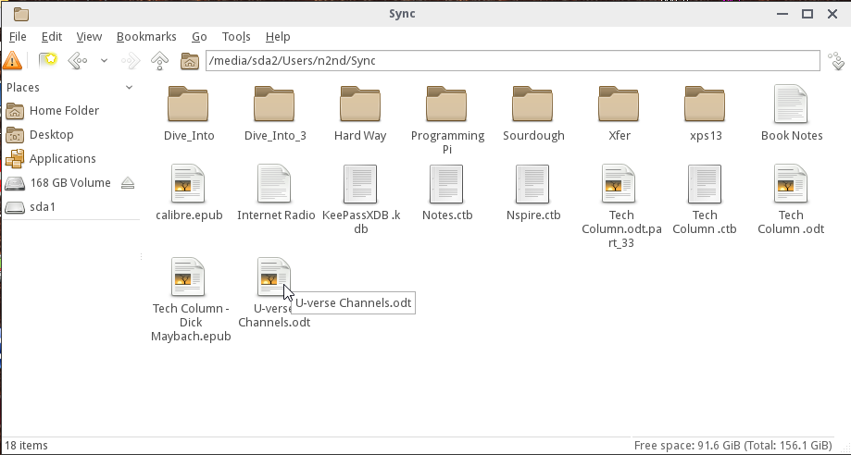
Screen 9. File Manager View of a Windows Directory.

You can delete files and directories and open a second window to drag and drop them to a different location. This is Linux however and the location box toward the top uses Linux instead of Microsoft conventions. In Windows “/media/sda2/Users/n2nd/Sync” would appear as “C:\Users\n2nd\Sync.” The only real caution here is that PartedMagic has no Trashcan; if you delete a file, it’s gone.

The Partition Editor is quite powerful, but be careful; see Screen 10.

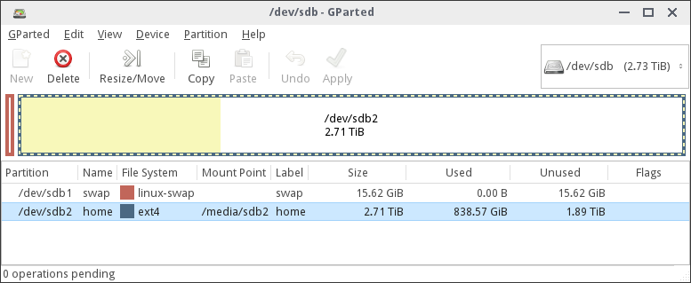
Screen 10. Partition Editor.

As you can see, this Linux disk has only a small swap partition and allocates most of its space to a home directory, which is less than 1/3 full (as shown by the yellow area). If your PC has more than one disk (as does this one), you access them by scrolling the box containing the text “/dev/sdb” at upper left. I most often use this tool for formatting new disks and memory sticks and resizing existing partitions. It is quite straight-forward to use, but if you haven’t done such things you should look for instructions and examples using an Internet search for “gparted.”

Using the Disk Cloning tool also requires care. Make a search for “clonezilla” for guidance. I’ve found that cloning an entire disk to a new one of the same or larger size is fairly straight-forward, as is copying a disk to an image file. Cloning a single partition though is more difficult, has many restrictions, and so far I haven’t been successful at it.

The virus scanner is Clam AV, which is used primarily in servers to avoid passing infected files on to others. As a result, it can only detect malware and can’t repair the files. I used it on a friend’s Windows machine that had become hopelessly infected when a teen-ager downloaded pirated audio files. I copied all their data to an external disk, checked it with Clam AV, and deleted the problem files. We then re-installed Windows and transferred their clean data files back to the PC. Windows users may wish to create a bootable CD-ROM or memory stick that is a malware repair tool such as AVG Rescue CD, http://www.avg.com/ww-en/download.prd-arl, or Norton Bootable Recovery Tool, https://security.symantec.com/nbrt/nbrt.aspx. You can download them while running PartedMagic by using Firefox for the download and UNetbootin to write a USB or Xfburn to burn a CD-ROM or DVD. However, you should create the tool and try it before you experience a problem. Running malware tools from a live medium is preferable to running them from your operating system, because in the latter case no programs on your disk are running, which means the malware can’t attempt to protect itself.

Selecting the Rescue item on the PartedMagic Applications menu produces the contents of Screen 11.

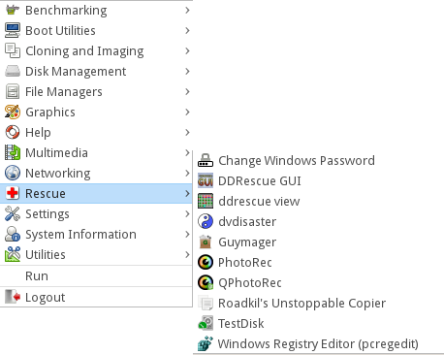
Screen 11. Rescue Menu.

These applications aid in the recovery of deleted files, and those lost through disk formatting, disk failure, and file system damage. I described the use of some in June, July, and August 2012. I won't repeat that here, but I will say that using them effectively requires some experience. You should practice by completely erasing a (preferably small) memory stick and writing a few files to it. Then try deleting them, reformatting the stick, or deleting its partition, and see what you can recover.

I recently experienced a hard disk failure, and used many of PartedMagic’s tools to replace it. SMART had reported that the system disk was beginning to fail, although all the errors were correctable. Modern hard disks have extensive error-correcting abilities. They also have spare storage blocks, and when a block begins to make consistent errors, even though they are correctable, that data is relocated to one of the spares and the storage map is changed. However, the operating system is not aware of this remapping. When a hard disk is delivered, the number of these remapped blocks is zero, so any reported remapping has occurred since manufacture. This is not necessarily true for solid state disks (SSDs), which may show relocated blocks when new. My failing disk showed 120 relocated blocks, and I decided it was time to order a replacement.

This PC has three disks, one for the system, one for the home directory that holds my data, and a removable one for backup. (Having this slot for SATA disks make cloning much easier; an alternative would be a USB-to-SATA adapter.) I had wanted to reorganize the storage for some time, and decided to replace both the system and home disks to make this easier. Normally, I would move the data from a disk to its replacement by inserting the new disk into the backup slot and cloning the failing one, which copies the entire contents of one disk onto a replacement. That wasn't possible here, because I planned to change the disk partitioning from Master Boot Record (MBR) to GUID Partition Table (GPT). MBR dates from the early 1980s and limits the maximum partition size to 2 TBytes, not optimal for my 3-TByte disks. I also wanted to partition them differently, and I had also decided to do a fresh install of Linux. The safe way for this was to all this was to use the PartedMagic File Manager to copy the disk contents file-by-file onto an external disk, install Linux, and copy the contents back. It took four and a half hours to transfer the almost 1 TByte at USB-3 speeds.
The next step was to install the new disks and partition them. (Linux, unlike Windows, almost always occupies more than one partition and frequently more than one disk.) Installing Linux went smoothly as usual, and the result was a nearly empty home directory. I then connected the USB drive and during the next four and a half hours loaded all my user data files. I was careful to do this before installing any new applications or running any existing ones. The first time a Linux application runs it uses the existing configuration file in the home directory if there is one, otherwise it creates a new one. (Windows configuration files tend to reside in the system area.) As a result, I wanted to have my old configuration files in place before I ran anything.
By this time I had two days invested in the project, and I finally took a look at the health of my new disks, only to find that one of them was defective with over 400 bad blocks – on the home disk of course, which now held a TByte of data. Again, the errors were correctable and so had not affected my data. Since the disk was partitioned exactly as I wanted, cloning was possible. I loaded the old disk (that was still good) in the backup slot, partitioned it, and proceeded with the cloning. Since these were both SATA disks, the data transfer was faster and completed in less than two hours. I had only to physically move the home disk to its internal slot and was done. Fortunately, I bought the defective disk on a money-back-if-not-satisfied basis and was out only the two hours to perform the cloning. In retrospect, I should have taken a few minutes to check the health of the disks before I invested the time to install them.
I had installed all my files, including years of tax returns, e-mail, legal documents, and much more personal information, on the defective disk that was now to be returned. You no doubt know that it is trivial to recover deleted files and only slightly more difficult to recover them from a disk that's been formated. The only sure way to remove them is to write over every byte on the disk, and this is the function of the Erase-Disk utility. Running this on a 3-TByte disk requires about eight hours, and that is what I did. I could have instead physically destroyed the disk, but I wanted that refund.

In this case, I used the PartedMagic file manager, disk health utility, partition editor, disk cloning, and erase disk applications, all of which were available on a single memory stick. It did take some time, but I was usually able to find something else to do while they ran. Without PartedMagic and some experience with it, I would have had little choice but to take the machine to a competent (in Linux) repair shop.

